
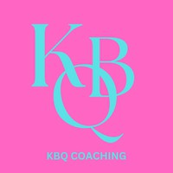

End of year reflections



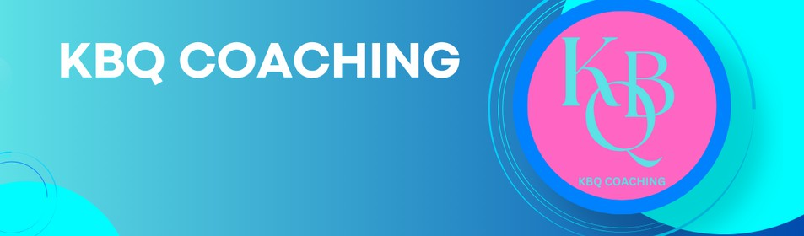

Hi!

In honour of new beginnings here's a handy little free gift to help you to reflect on the past year and plan for the year ahead.

The questions included in this booklet are designed to get you thinking about what you have achieved in 2024, what you would like to achieve in 2025, and how you intend to go about reaching your intended goal(s).

Things change all the time so you may find that some of your answers may change over the course of the year, which is absolutely fine, this booklet is simply to help get you started. Also, don't feel that you need to answer all the questions right away. You may need time to think about a few things and speak to a few people - in fact, I highly recommend you do exactly that!

Whether you're a regular end of year reflector/new year planner, or this is the first time you've engaged in the end of year reflection process, I hope you find this booklet useful for your development.

If you'd like to give one-to-one coaching a try in 2025, you can find out more about KBQ Coaching at kbqcoaching.com or by scanning the QR code below.

In the meantime, I wish you all the best for the coming year!




2024

REFLECTIONS

What went well this year?

What didn’t go so well and what lesson(s) did you learn?

What are you most proud of this year?

2024

REFLECTIONS

What do you need to work on?

Who is the person/are the people who have been a source of support for you this year and how?

Who have you been a source of support to this year and how?

2024

REFLECTIONS

What key things have you learned about yourself this year?

What piece(s) of advice will you be taking with you into 2025?

A film, book, or song that sums up this year for you...

2024

REFLECTIONS

A film, book or song that sums up how you will be approaching 2025...


2025 PLANNING

What is/are your goal(s) for 2025? (Make sure the goal is SMART: Specific, Measurable, Achievable, Realistic and Time-bound)

On a scale of 1 to 10 where 1 = ‘not very’ and 10 = ‘extremely’ how important is it for you to achieve your goal(s)?

What do you already have that will help you to achieve your goal(s)? (Think about your skills, equipment, experience, attributes, people, contacts etc that you currently have)

2025 PLANNING
What don’t you have to help you achieve your goal(s) and how can you realistically acquire what you need?

Can you identify specific people in your support network who may, directly or indirectly, be able to help you achieve your goal(s)?

What will you do to keep yourself motivated while achieving your goal(s)?

2025 PLANNING
What are the pros and cons of achieving your goal(s)?

What may happen if you don’t achieve your goal(s)?

2025 PLANNING

Who will you turn to for support and motivation during the process?

When do you intend to start the process? (Please write a date)

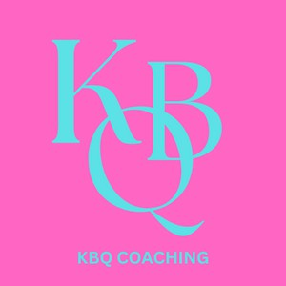

Copyright © 2024 Karice Baker-Quow

